DBMS Course Project Report on
“Lost & Found Portal”
SUBMITTED IN PARTIAL FULFILLMENT OF THE REQUIREMENTS FOR THE DEGREE OF
BACHELOR OF TETECHNOLOGY
IN

“Information Technology”
OF
VISHWAKARMA INSTITUTE OF TECHNOLOGY

Savitribai Phule Pune University

Atharva Lanke (12412594)

Anuraj Lonkar(12410073)

Aditya Karhadkar(12415044)

Atharva Khairnar(12415058)

Swaraj Langhe(12415071)

UNDER THE GUIDANCE OF
“Prof.Aparna Sawant”

DEPARTMENT OF INFORMATION TECHNOLOGY

BANSILAL RAMNATH AGARWAL CHARITABLE TRUST’S
VISHWAKARMA INSTITUTE OF TECHNOLOGY
(An Autonomous Institute affiliated to Savitribai Phule Pune University)

2025 - 2026

BANSILAL RAMNATH AGARWAL CHARITABLE TRUST’S

VISHWAKARMA INSTITUTE OF TECHNOLOGY
(An Autonomous Institute affiliated to Savitribai Phule Pune University)

PUNE – 411037



CERTIFICATE

This is to certify that the Course Project titled “Lost & Found Portal” submittet.by.AtharvaLanke(12412594),AnurajLonkar(12410073),AdityaKarhadkar(12415044), Atharva Khairnar(12415058), Swaraj Langhe(12415071) is in partial fulfillment for the award of Degree of Bachelor of Technology in Department of Information Technology of Vishwakarma Institute of Technology, Savitribai Phule Pune University. This project report is a record of bonafide work carried out by him/her under my guidance during the academic year 2025-26.

Prof. Aparna R. Sawant Prof. Pravin Futane Internal Guide Head,IT
Place: VIT, Pune

Date:4/25/2026

Bansilal Ramnath Agarwal Charitable Trust’s

Vishwakarma Institute of Technology, Pune-37
Department of Information Technology

PROJECT DETAILS

Group No : 14
Members:

Sr. No. | Class & Div. | Roll No. | G.R.No. | Name of Student | Contact No. | Email ID
1 | SY-IT-C | 67 | 12412594 | Atharva Popat Lanke | 8080567978 | atharva.lanke24@vit.edu
2 | SY-IT-C | 69 | 12410073 | Anuraj Bapurao Lonkar | 8623938581 | anuraj.lonkar24@vit.edu
3 | SY-IT-C | 71 | 12415044 | Aditya Girish Karhadkar | 8329115445 | aditya.karhadkar242@vit.edu
4 | SY-IT-C | 73 | 12415058 | Atharva Shrivallabh Khairnar | 7083689787 | atharva.khairnar242@vit.edu
5 | SY-IT-C | 76 | 12415071 | Swaraj Ashok Langhe | 7249165883 | swaraj.langhe24@vit.edu

Academic Year : Year:2025-2026
Project Title : Lost And Found Portal
Project Area : DBMS
Internal Guide : Prof. Aparna R. Sawant

Signature of Internal Guide

ACKNOWLEDGEMENT

I would like to express my sincere gratitude to all those who have supported and guided me throughout the completion of this Database Management System (DBMS) project on “Lost & Found Portal”. This project would not have been possible without the valuable assistance and encouragement from many individuals.

Firstly, I would like to thank my project guide/teacher for providing continuous guidance, valuable suggestions, and motivation at every stage of the project. Their insights helped me understand the core concepts of database design, normalization, and implementation effectively.
I am also grateful to my institution for providing the necessary resources, infrastructure, and a conducive learning environment that made this project possible.
I would like to extend my appreciation to my friends and peers who contributed with their ideas, feedback, and support during the development phase.
This project involved designing and implementing a full-stack system using technologies such as Node.js, Express, and MySQL, focusing on efficient data handling, secure user authentication, and real-time tracking of lost and found items . Working on this project has enhanced my understanding of database management, backend integration, and practical application development.

- Introduction

In today’s fast-paced world, people frequently misplace personal belongings such as wallets, mobile phones, documents, and other valuable items. Managing lost and found items manually is often inefficient, time-consuming, and prone to errors. To address this issue, this project presents a “Lost & Found Portal”, a web-based application designed using Database Management System (DBMS) concepts to efficiently handle the reporting, tracking, and management of lost and found items.
The primary objective of this system is to provide a centralized platform where users can report lost items or submit details of items they have found. The system maintains structured records in a relational database, ensuring efficient storage, retrieval, and management of data. It also allows users to track items using unique tracking IDs, making the process more organized and transparent.
This project is developed using modern technologies such as Node.js and Express for backend operations, MySQL as the database, and HTML, CSS, and JavaScript for the frontend interface . The system implements key DBMS concepts such as entity relationships, normalization, data integrity, and secure data handling.
Additionally, the portal includes features like user authentication, item categorization, status tracking, and administrative controls. These features ensure that only authorized users can access or modify data, thereby maintaining security and reliability.
Overall, the Lost & Found Portal demonstrates the practical implementation of database management principles in solving real-world problems by providing an efficient, user-friendly, and scalable solution for managing lost and found items.

- Methodology

The development of the “Lost & Found Portal” follows a structured and systematic methodology to ensure efficient implementation of Database Management System (DBMS) concepts along with full-stack web development practices.
1. Requirement Analysis:
The first step involved identifying the problem of managing lost and found items manually. The system requirements were gathered, including user registration, login, reporting lost/found items, tracking items using unique IDs, and admin controls. Both functional and non-functional requirements were clearly defined.
2. System Design:
The overall system architecture was divided into three layers:
- Frontend: Developed using HTML, CSS, and JavaScript for user interaction.
- Backend: Built using Node.js and Express to handle business logic and API requests.
- Database: Designed using MySQL to store and manage structured data efficiently .
Entity-Relationship (ER) diagrams and relational schemas were created to define the structure of the database.
3. Database Design:
The database consists of three main tables: Users, Items, and Claims. Proper normalization (up to 3NF) was applied to eliminate redundancy. Primary keys and foreign keys were used to establish relationships and maintain data integrity.
4. Development:
The system was developed in modules:
- User authentication (registration/login)
- Item reporting (lost/found)
- Item browsing and filtering
- Tracking system using tracking IDs
- Admin functionalities
Backend APIs were created for handling requests, and frontend pages were connected using JavaScript.
5. Testing:
The application was tested for correctness and performance. All features such as login, item reporting, and tracking were verified. Bugs and errors were identified and fixed to ensure smooth functionality.
6. Deployment:
After testing, the application was configured for deployment with proper database connections, environment variables, and server setup.
7. Maintenance & Improvement:
The system is designed to be scalable and can be improved with additional features like notifications, image uploads, and advanced search in the future.
This methodology ensured that the project was developed in a well-organized manner, resulting in a reliable and efficient Lost & Found Portal.

3.Structure of each table used

The database for the “Lost & Found Portal” is designed using a relational model with three main tables: Users, Items, and Claims. Each table is structured with appropriate fields, primary keys, and foreign keys to maintain data integrity and relationships.

1. Users Table
This table stores the details of all registered users in the system.
Field Name | Data Type | Key | Description
user_id | INT (AUTO_INCREMENT) | Primary Key | Unique ID for each user
full_name | VARCHAR(100) |  | Name of the user
email | VARCHAR(100) | Unique | User’s email address
password_hash | VARCHAR(255) |  | Encrypted password
role | VARCHAR(20) |  | Role (user/admin)
created_at | TIMESTAMP |  | Account creation date

2. Items Table
This table stores information about lost and found items reported by users.
Field Name | Data Type | Key | Description
item_id | INT (AUTO_INCREMENT) | Primary Key | Unique ID for each item
tracking_id | VARCHAR(20) | Unique | Unique tracking ID (e.g., LF-XXXX)
user_id | INT | Foreign Key | References Users(user_id)
item_type | VARCHAR(10) |  | Type (lost/found)
item_name | VARCHAR(100) |  | Name of the item
category | VARCHAR(50) |  | Item category
location | VARCHAR(150) |  | Location where item was lost/found
item_date | DATE |  | Date of lost/found
description | TEXT |  | Additional details
contact_email | VARCHAR(100) |  | Contact email
status | VARCHAR(20) |  | Status (pending/resolved/closed)
created_at | TIMESTAMP |  | Record creation time
updated_at | TIMESTAMP |  | Last update time

3. Claims Table
This table manages claims made by users for lost or found items.
Field Name | Data Type | Key | Description
claim_id | INT (AUTO_INCREMENT) | Primary Key | Unique ID for each claim
item_id | INT | Foreign Key | References Items(item_id)
user_id | INT | Foreign Key | References Users(user_id)
claim_description | TEXT |  | Details provided by claimant
claim_status | VARCHAR(20) |  | Status (pending/approved/rejected)
created_at | TIMESTAMP |  | Claim creation time

Note:
- Primary Keys ensure uniqueness of records in each table.
- Foreign Keys maintain relationships between tables.
- Proper constraints and normalization techniques are applied to reduce redundancy and improve consistency .

4.Normalized form of project database

The database used in the “Lost & Found Portal” is designed following normalization principles to ensure minimal redundancy, improved data integrity, and efficient data management. The database is normalized up to the Third Normal Form (3NF).

1. First Normal Form (1NF)
A table is said to be in 1NF if:
- All attributes contain atomic (indivisible) values
- Each record is unique
- There are no repeating groups or multivalued attributes
Application in Project:
- Each table (Users, Items, Claims) contains atomic values (e.g., one email per user, one item per record).
- Repeating data such as multiple items or claims are stored as separate rows instead of columns.
- Each table has a primary key (e.g., user_id, item_id, claim_id) ensuring uniqueness.

2. Second Normal Form (2NF)
A table is in 2NF if:
- It is already in 1NF
- All non-key attributes are fully functionally dependent on the primary key
Application in Project:
- In all tables, non-key attributes depend entirely on their respective primary keys.
  - For example, in the Items table, attributes like item_name, category, and location depend only on item_id.
- There are no partial dependencies since each table uses a single-column primary key.

3. Third Normal Form (3NF)
A table is in 3NF if:
- It is already in 2NF
- There are no transitive dependencies (non-key attributes should not depend on other non-key attributes)
Application in Project:
- User details are stored only in the Users table, avoiding duplication in other tables.
- Item-related data is stored in the Items table, and claim-related data is stored in the Claims table.
- Relationships are maintained using foreign keys (user_id, item_id) instead of duplicating data.
- For example, in the Claims table, user and item information is referenced via IDs instead of storing full details again.

Conclusion
The database structure of the project satisfies the conditions of Third Normal Form (3NF). This ensures:
- Reduced data redundancy
- Improved consistency and integrity
- Efficient query performance
- Easier maintenance and scalability
By applying normalization techniques, the system achieves a well-structured relational database design suitable for real-world applications .

5.Screenshots of results
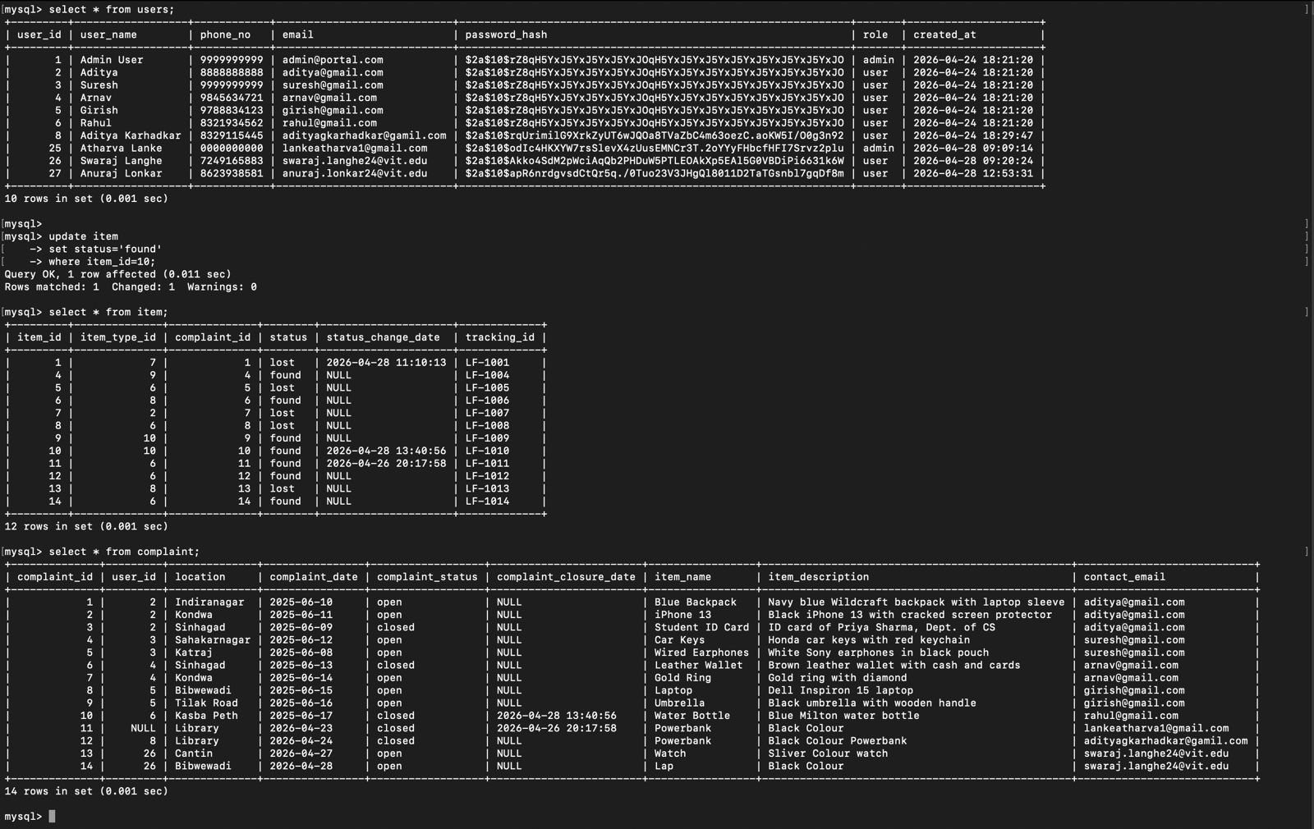
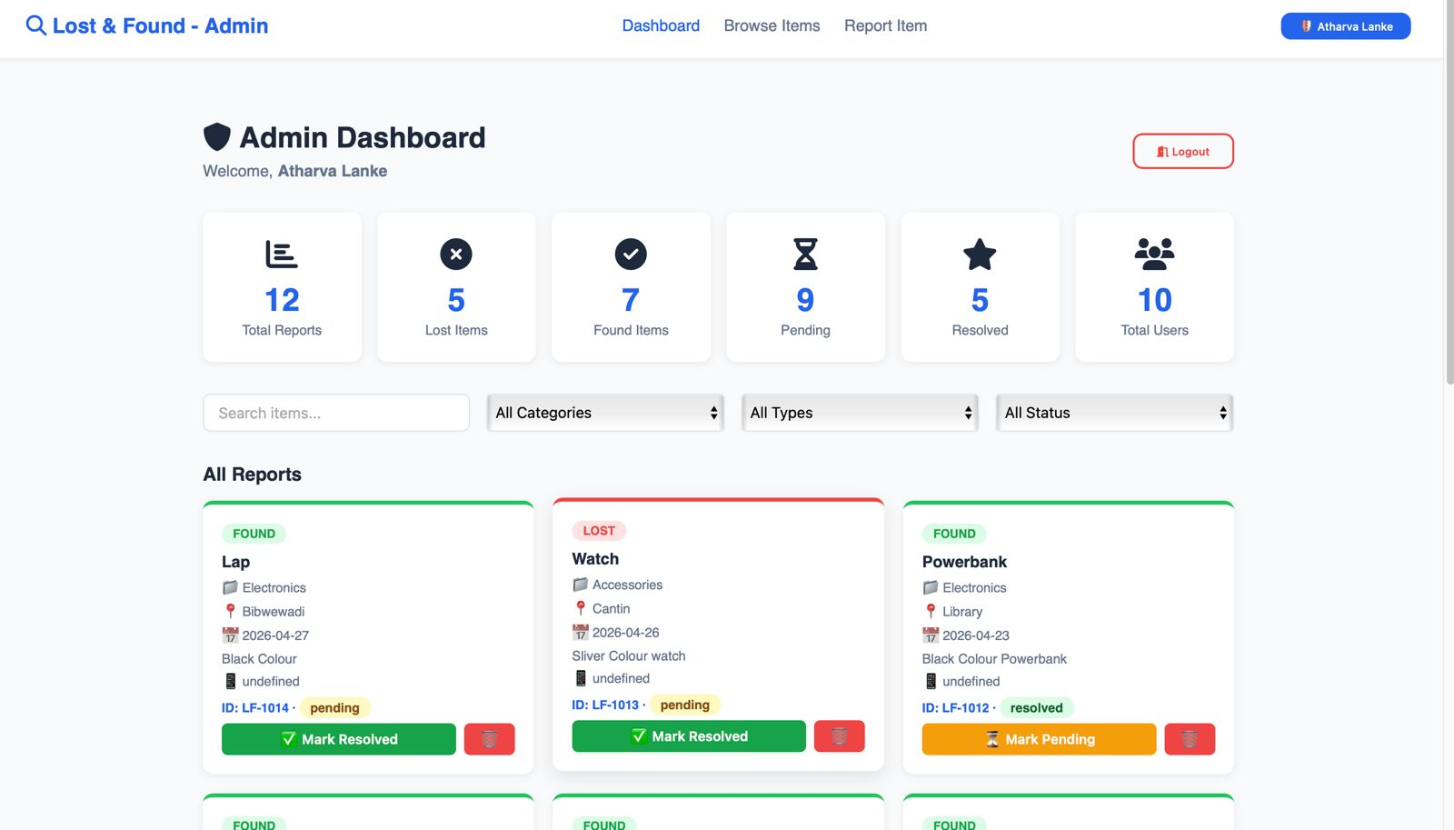
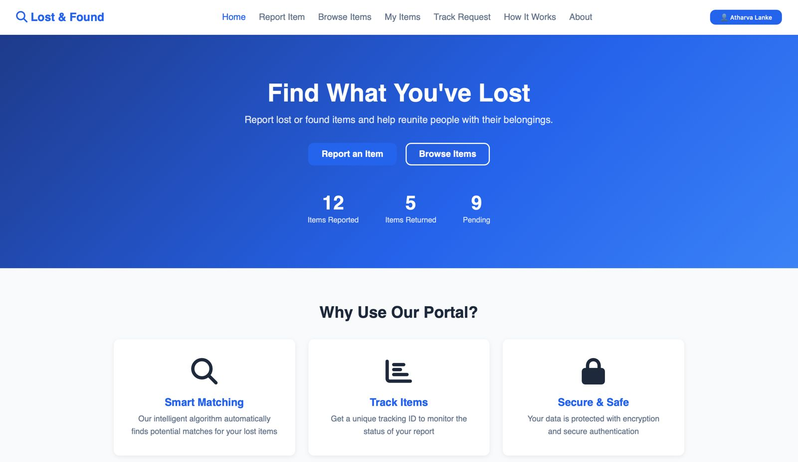

Conclusion

The “Lost & Found Portal” project successfully demonstrates the practical implementation of Database Management System (DBMS) concepts in solving a real-world problem. The system provides an efficient and user-friendly platform for reporting, tracking, and managing lost and found items in a structured manner.
Through this project, key DBMS principles such as data modeling, normalization, relational schema design, and the use of primary and foreign keys have been effectively applied. The database is designed up to the Third Normal Form (3NF), ensuring minimal redundancy, data consistency, and efficient data retrieval.
The integration of frontend and backend technologies along with a MySQL database enabled the development of a complete full-stack application. Features like user authentication, item tracking using unique IDs, and status management enhance the usability and reliability of the system .
Overall, this project not only improves the traditional process of handling lost and found items but also provides a scalable and secure solution. It serves as a strong example of how DBMS concepts can be applied in real-world applications to build efficient and practical systems.
Future enhancements such as image uploads, automated notifications, and advanced search features can further improve the system and make it more robust.
In conclusion, the project has been a valuable learning experience, strengthening both theoretical understanding and practical skills in database management and application development.

Future Scope

The “Lost & Found Portal” has been successfully developed with essential features for managing lost and found items. However, there is significant scope for further enhancements to improve functionality, usability, and scalability.
One of the major future improvements could be the integration of an image upload feature, allowing users to attach photos of lost or found items. This would make identification more accurate and increase the chances of successful recovery.
Another important enhancement is the implementation of email and real-time notifications, which can alert users when a matching item is found or when the status of their report changes. This would improve user engagement and responsiveness of the system.
The system can also be upgraded with an advanced search and filtering mechanism, enabling users to search items based on multiple criteria such as date, category, location, and keywords. Incorporating AI-based matching algorithms could further automate and improve the accuracy of matching lost and found items.
Additionally, the introduction of a mobile application version would make the platform more accessible and convenient for users. Integration with GPS services could allow location-based tracking and reporting of items.

REFERENCES

- MySQL Documentation – MySQL Reference Manual. Available at: https://dev.mysql.com/doc/
- Node.js Official Documentation. Available at: https://nodejs.org/
- Express.js Guide & API Reference. Available at: https://expressjs.com/
- MDN Web Docs – HTML, CSS, and JavaScript Tutorials. Available at: https://developer.mozilla.org/
- Silberschatz, A., Korth, H. F., & Sudarshan, S. – Database System Concepts (DBMS textbook)
- Elmasri, R., & Navathe, S. B. – Fundamentals of Database Systems
- Project Documentation and Source Code – Lost & Found Portal System
- Online Tutorials and Learning Resources – W3Schools (https://www.w3schools.com/) for SQL and Web Development basics

